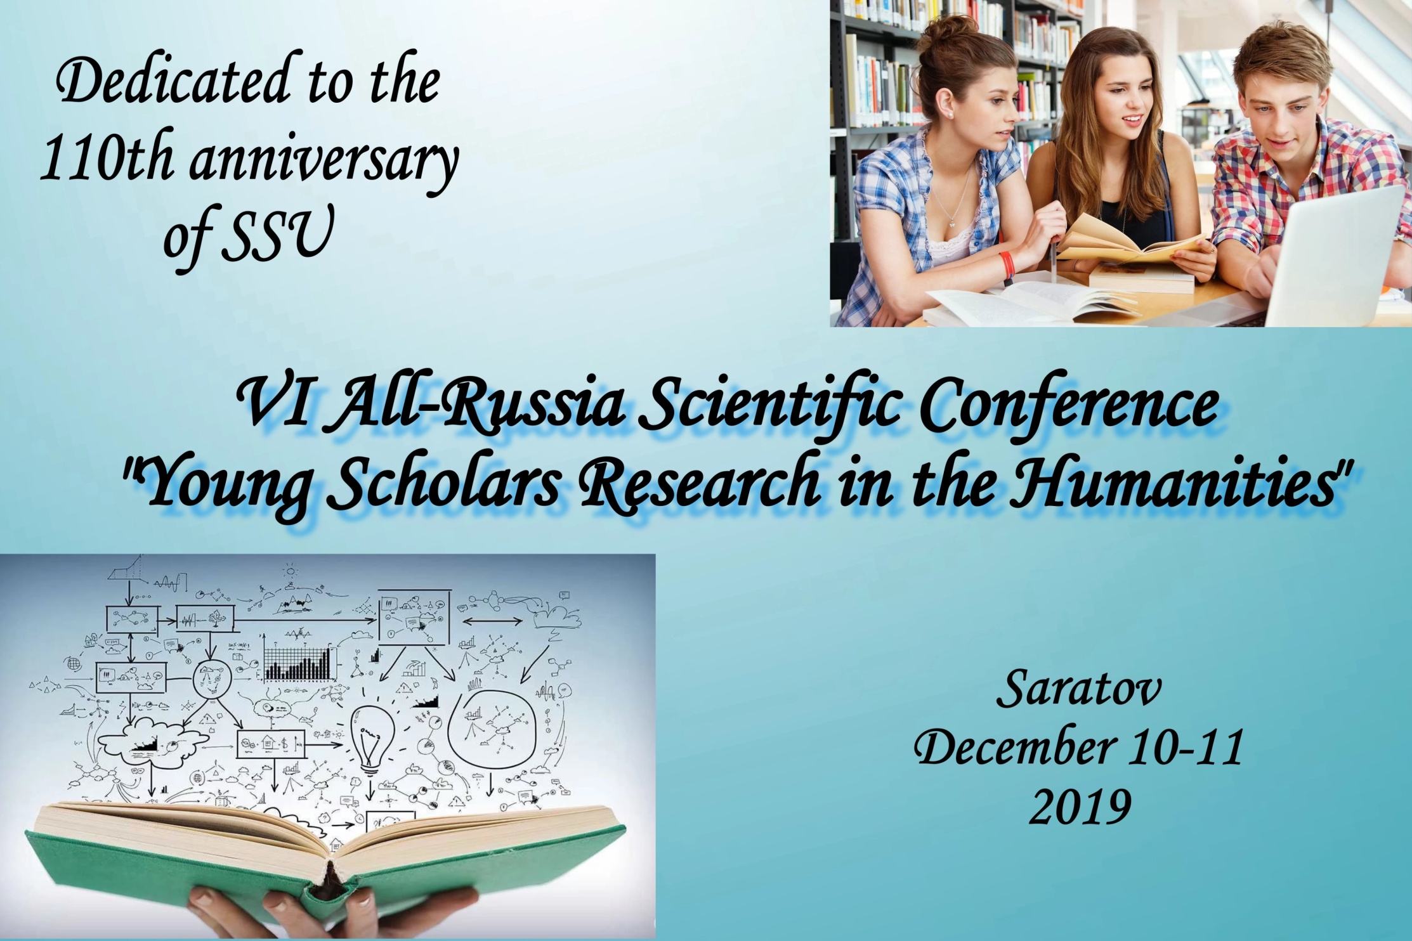December 10, 2019, Tuesday
Building 12, Room 134
15.30-17.30
Pre-Conference Event: Workshops
Title of the Workshop | Presenter
Пишем мотивационное письмо | Наталья Алексеевна Кубракова, к.филол.наук, доцент кафедры английского языка для гуманитарных направлений и специальностей
Как проверить достоверность информации | Александра Васильевна Раева, к.филол.наук, доцент кафедры общего литературоведения и журналистики
Как написать эффективную англоязычную аннотацию научной статьи | Ирина Николаевна  Сипакова, к.филол.наук, доцент, зав. кафедрой английского языка для гуманитарных направлений и специальностей
CONCERT: performers – students of the Institute of History and International Relations

December 11, 2019, Wednesday
Time | Event |  |  | Place
09.30-10.00 | REGISTRATION |  |  | 10A, Volskaya Street,  Building 12,  Room 110
10.00-10.10 | Greetings
PLENARY SESSION
10.10-10.40 | “Об адекватном переводе стилистических средств латинской прозы Петрарки” | Presenter: Лариса Михайловна Лукьянова, доцент кафедры русской и зарубежной литературы Саратовского государственного университета им. Н.Г. Чернышевского
10.40-11.10 | “Воспитание реформаторов, или как стать выдающимся государственным деятелем (на примере семьи Милютиных)” | Presenter: Елена Николаевна Морозова, доктор исторических наук, профессор кафедры отечественной истории и историографии Саратовского государственного университета им. Н.Г. Чернышевского
11.10-11.40 | “Медиаграмотность как элемент современного гуманитарного знания” | Presenter: Александр Александрович Казаков, кандидат политических наук, доцент кафедры политических наук Саратовского государственного университета им. Н.Г. Чернышевского
11.40-12.10 | “Academic Research in Humanities: Issues and Challenges” | Presenter: Денис Сергеевич Алексеев, кандидат исторических наук, доцент кафедры международных отношений и внешней политики России Саратовского государственного университета им. Н.Г. Чернышевского
BREAK
12.20-15.20 | Panel Discussion 1 Research in Sociology, Tourism and Literature Studies |  | Building 12, Room 113
 | Panel Discussion 2 Research in Jurisprudence, Political Studies and Philosophy |  | Building 12, Room 125
 | Panel Discussion 3 Research in International Studies and History |  | Building 12, Room 110
 | Panel Discussion 4 Linguistic Research of English in Second Language Learning |  | Building 16, Room 406

Panel Discussions

Panel Discussion 1 (Building 12, Room 113)
Time-limit: 10 minutes

Chairpersons:
Bronislava R. Mogilevich (Doctor of Sociology, Professor, Chair of English for Humanities, SSU)
Ekaterina N. Zakharova (Candidate of History, Associate Professor, Chair of English for Humanities, SSU)

Biryukov Dmitry, Nerush Anton
Economic Behavior of Online Gamers
Bogdanova Anna
Gender and Age, as Factors Influencing Interest and Preferences in Cinematography
Chernysheva Veronika
Ivan Bunin`s Early Poetry in the Perception of the Contemporaries: оn the Problem Definition
Dorofeeva Elena
Digital Technologies in Museums of the Modern Type and Their Influence on Tourism Development in Russia
Golubosh Olesya Sergeevna
The Problem of Patriotism among Young People as a New Challenge to the Modern Education System of Russia.
Khomutova Yana
Art-Therapy as a Way of Museum Environment Perception by People with Disabilities
Kuzmicheva Victoria
Digital Technologies in Tourism
Pyataeva Ekaterina
Tourism Development in Nizhny Novgorod Region
Shatokhina Irina, Magakian Angelina
Runglish as One of the Consequences of Tourism Development
Shtadler Olga
The Role of Event Tourism in Creating a Territory's Brand
Timofeyeva Anastasiya
Psychological and Pedagogical Support and Education of Children with Visual Impairments: the Experience of Saratov
Vasyurenko Kirill
How the Tattoo Function Changed in Modern Society: To Get a Tattoo or not to Get

Panel Discussion 2 (Building 12, Room 125)
Time-limit: 10 minutes

Chairpersons:
Natalia A. Kubrakova (Candidate of Philology, Associate Professor, Chair of English for Humanities, SSU)
Daria V. Ivanova (Candidate of Philology, Associate Professor, Chair of English, SSU)

Berdnikova Anastasia
Organization and Legal Regulation of the System of Digital Marking and Traceability of Goods by the Customs Authorities of the Russian Federation
Chernaya A. S.
Risk-Generating Aspect of the Ancient Greek Mythology
Dolgova Darya
The Role of English in Eurasian Integration
Gavrilova Anna
The Catechetical Potential of Diocesan Internet Resources in Russia
Ikzalieva Lilia, Popova Yulia
Legal Clinical Training in Russia and Great Britain
Konovalova Darina
The Nature of Religion
Kostritskaya Taisa
Is Philosophy Androcentric, or Can «Man» Be «Woman»?
Kravtsova Elizaveta
Racial Issues among the Young: Alarming News Reports from the USA
Lapina Oksana
The World Practice of Combating Suicidal Communities in the Internet
Obycheva Darya
How to Become Customs Officers in the USA
Tsybin Danil
Legal Basis for the Customs Declaration of Goods

Panel Discussion 3 (Building 12, Room 110)
Time-limit: 10 minutes

Chairpersons:
Denis S. Alekseev (Candidate of History, Associate Professor, Institute of History and International Relations, Chair of International Relations and Russian Foreign Policy, SSU)
Rozalia M. Bazyleva (Candidate of Philology, Associate Professor, Chair of English for Humanities, SSU)

Abduraupova Azizakhan
The Job of My Dream
Agafonova Arina
The Conceptual Opposition “Self-Alien” in the Political Discourse of the UK (UK – USA)
Alaeva Daria
Portraits of Elizabeth I Tudor
Avetisyan Eleonora
Peculiarities of the Work with Media within the Professional Sphere
Borisov Aleksei
Migration policy of Germany in the XXI Century
Kadukhina Polina
Prospects of Development of Russian-Chinese Relations in the Shanghai Cooperation Organization (SCO)
Katsia Vianor
New International (World) Economic Order (NIEO)
Sdobnova Kseniia
The European Union: Nation Branding
Tikhonova Valeriya
China in Arctic: Military Player or Peace Maker
Vinogradov Andrei
Japan’s Cultural Diplomacy to the Russian Federation after 2014
Zaikina Varvara
The Northern Sea Route as a Sphere of Clash in Interests between the USA, China and the Russian Federation in the Arctic Region
Starostina Inna
News from the Front

Panel Discussion 4 (Building 16, Room 406)
Time-limit: 10 minutes

Chairpersons:
Michael V. Zolotarev ( Candidate of Philology, Associate–Professor,
the Department of the English Language and Methodology, SSU)
Galina A. Nikitina ( Candidate of Philology, Associate–Professor, Head of the Department of the English Language and Methodology, SSU)

Avdeeva Lira
Deviation from the Grammatical Norm in the English-Language Song Discourse
Babadzhanyan Lilit
The Practical Aspects of Teaching Grammar of the English Language in Elementary School
Fomicheva Kristina
Practical Realization of the Basic Principles of Differentiated Learning
Garanina Polina
Method of Scaffolding in Teaching a Foreign Language
Kasatkina Olga
Ways of Teaching Linguistic Inference in ELT
Khokhlova Maria
Effective Ways of Using Internet Resources in Developing Cross-Cultural Competence
Kopylova Alevtuna
Development of Multicultural Awareness of Students in FLT
Piskun Yakov
Precedent Phenomena as Elements of the Worldview of Native Speakers-Representatives of Different Linguocultures
Popp Arina
A National Corpus as a Reflection of the Language at the Modern Stage of its Development.
Pronina Polina
Origins of Language in Mythology
Ryzhova Valentina
The Peculiarities of Lexical and Stylistic Means of Scent Perception in the English Literary Discourse.
Shapovalova Anastasia
Close Reading Skills Development in EL
Strogoleva Diana
Teaching English to Young Leaners via Skype: Planning the Course

